**Tên: Hồ Chí Nguyên**

**MSSV: 2251050048**

**Link Github:** <https://github.com/Nguyeniris123/TH1_KTPM>

**Kiểm thử phần mềm buổi 1**

* Code chức năng 1:

* Tạo repository và add vào github:

* Commit và push chức năng 1 code lên github:

* Mời bạn:

* Code chức năng 2:

* Tạo branch mới và commit, push chức năng mới vào branch mới:

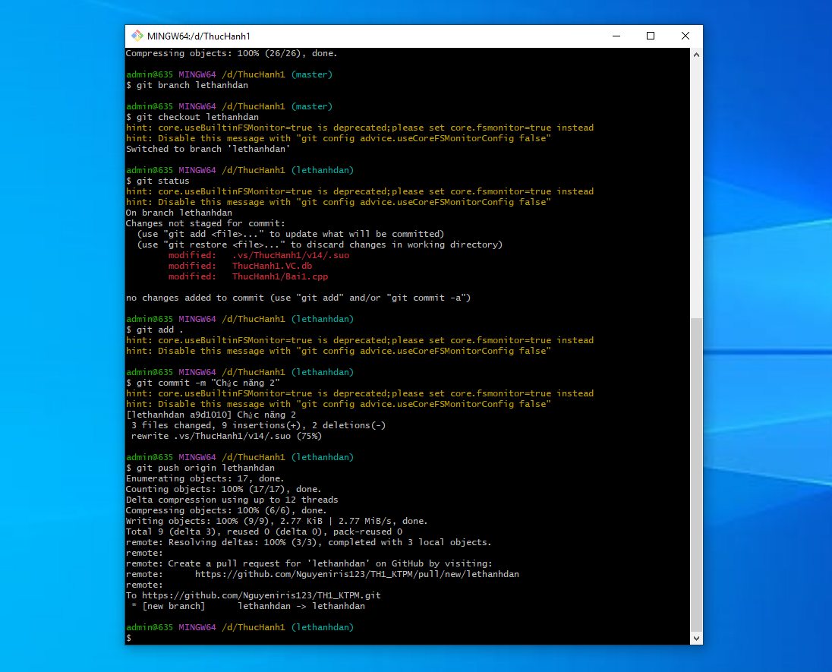

* Merge branch mới lethanhan vào branch Master:

